CMP6200/DIG6200

Individual Undergraduate Project 2024–2025

**A2: Literature Review and Methods**

Gamifying movements beneficial for stroke rehabilitation



Course: Computer Games Technology

Student Name: James Richard Bland

Student Number: 22142846

Supervisor Name: Xi Guo

Contents

1 Report Introduction 2

1.1 Aim and Objectives 2

1.2 Project Aim 2

1.3 Project Objectives 2

1.4 Literature Search Methodology 3

2 Literature Review 6

2.1 Themes 6

2.2 Review of Literature 6

2.2.1 Gamified Rehabilitation for Stroke 6

2.2.2 Digital application to enhance motivation of the therapy. 8

2.2.3 Digital application to enhance upper limb movement. 8

2.2.4 Haptics for rehabilitation game 9

2.2.5 Multiplayer Games for Stroke Rehabilitation. 9

2.3 Summary 10

2.3.1 Scope of the games 10

2.3.2 Prototype design 11

3 Appendix 14

3.1 Gantt Chart 17

4 References 17

5 Bibliography 19

# Report Introduction

Upper limb stroke rehabilitation typically sees heightened implementation after patients are discharged from the hospital. After returning home a patient should undertake home therapy programmes to further recover and better their quality of life.

The brain has the most ability to repair itself in the first 3 months’ post stroke (The University of British Columbia: 2021: 5). Therefore it is vital that the patient completes as much therapy in this time as possible to maximise recovery. Currently there are home therapy programmes, however contemporary home therapy programmes do not provide high levels of motivation to the patient. This can lead to the therapy being neglected resulting in sub-optimal recovery or potentially other implications such as learned non-use syndrome (The University of British Columbia, 2021: 13).

Therefore, it is important to explore ways to provide more motivation to the patient. Gamification and even more so multiplayer gamification is one such way this goal can be achieved.

This report will investigate previous gamified therapies, their methods, and their effectiveness. This information will be crucial to the design of the artefact.

## Aim and Objectives

## Project Aim

The aim of this project is to produce a multiplayer game, utilizing etee controllers, which encourages movements beneficial to Upper Limb (UL) stroke rehabilitation and provides more motivation than conventional home therapy treatments.

## Project Objectives

|  |  |
| --- | --- |
| Objective Number | Objective |
| 1 | Identify characteristics of effective rehabilitation treatments. |
| 2 | Identify movements beneficial to providing effective rehabilitation treatment. |
| 3 | Use knowledge gained from objectives 1 and 2 to design, scope and plan the development of the game |
| 4 | Develop the game using the designs and plans produced in the previous objective using agile project management techniques |
| 5 | Test the game with a group of adults to observe the repetitions of the intended motions and motivation to play the game relative to other therapy options. |
| 6 | Use the knowledge learned from testing to evaluate the projects outcomes. |
| 7 | Summarize and report writing |

## Literature Search Methodology

To find relevant and useful papers PICOC in conjunction with PRISMA will be used to find and screen papers. PICOC is “a method used to describe the five elements of a searchable question” (“What is a PICOC? » CEBMa,” n.d.). PICOC will be used to help think about and create searchable terms which will be used to find and screen papers as per the PRISMA guidelines.

PRISMA provides a set of guidelines ensuring systematic reviews and meta-analyses are comprehensive, transparent and reproducible. Prisma guidelines will be used in the selection process of relevant papers.

Below is the PICOC acronym expanded in relation to this paper.

|  |  |
| --- | --- |
| PICOC element | Expanded acronym |
| Population (Who?) | General population sample |
| Intervention (What or How?) | A bespoke multiplayer gamified software solution designed to facilitate and encourage upper limb movements conducive to stroke rehabilitation |
| Comparison (Compared to what?) | Conventional physical therapy techniques used for upper limb rehabilitation (e.g. traditional exercises) |
| Outcome (What are you trying to accomplish / improve?) | Users perform therapeutic upper limb movements with increased motivation compared to conventional therapy. |
| Context (in what kind of organization / circumstances?) | Using the software for rehabilitation in a home setting. |

Using this PICOC structure, keyword search terms and permutations can be generated and used in databases to find potentially useful literature.

|  |  |  |  |
| --- | --- | --- | --- |
| Search term permutation | Input to database search | Searched database | Literature retrieved count |
| (Population) AND (Intervention) | (general AND population OR stroke AND patients) AND (gamified AND rehabilitation OR virtual AND therapy) | Scopus | 2 |
| (Outcome) AND (Context) | (upper AND limb AND movements OR patient AND engagement) AND (home-based OR in-home) | Scopus | 19 |
| (Intervention) AND (Comparison) | (game-based AND software OR digital AND therapy) AND (traditional AND rehabilitation OR conventional AND therapy) | Scopus | 4 |
| (Intervention) AND (Outcome) AND (Context) | (gamified AND rehabilitation OR virtual AND therapy OR game-based AND software OR digital AND therapy) (motor AND improvement OR adherence) AND (home AND rehabilitation) | Scopus | 1 |
| (Population) AND (Intervention) AND (Outcome) AND (Context) AND NOT (Exclusions) | (general population OR stroke patients) AND (gamified rehabilitation OR virtual therapy OR Serious Games) AND (upper limb movements OR patient engagement) AND (home-based OR in-home) NOT (lower limb) NOT (clinical) AND (multiplayer OR multi-user) | Google Scholar | 247 |

These searches retrieved a total of 273 pieces of likely relevant literature. These results will then be screened using inclusion and exclusion criteria.

|  |  |
| --- | --- |
| Inclusion Criteria | Exclusion Criteria |
| Literature focused on gamified or digital interventions for UL rehabilitation | Studies not related to stroke or upper limb rehabilitation |
| Studies evaluating repetitions or engagement as outcomes | Interventions not utilizing gamified or digital methods |
| Research involving at-home or remote-based rehabilitation | Studies with a focus solely on lower limb |
| Papers published in peer-reviewed journals | Research involving clinical settings exclusively |
| Studies that compare interventions to traditional rehabilitation methods | Result past the second page of google scholar |
|  | Research focusing on robotic intervention |

Records identified from*:

Databases (n = 273)

Registers (n = 0)

Found personally through arbitrary searches (7)

Backward snowballing (3)

Records removed *before screening*:

page of google scholar (n = 227)

duplicates removed (n = 1)

Records screened

(n = 52)

Records excluded**

(n = 18)

Reports sought for retrieval

(n = 37)

Reports not retrieved

(n = 7)

**Identification of studies via databases and registers**

**Identification**

**Screening**

**Included**

Reports assessed for eligibility

(n = 27)

Reports excluded:

Literature focuses on robotic rehabilitation (n = 3)

Literature did not focus on non-digital based interventions (n = 2)

Studies included in review

(n = 25)

Reports of included studies

(n = x)

# Literature Review

## Themes

|  |  |
| --- | --- |
| Theme | Relevance |
| Gamified rehabilitation in stroke | See what gamification techniques have been applied in other projects to inform the approach to gamification in this project. |
| Digital application to enhance motivation of the therapy | The goal of this project is twofold, to create a therapy application where the user performs an adequate amount of movement while experiencing more motivation to do so. Knowing what game elements users respond well to will be important in creating an experience that users enjoy more than non-game therapies. |
| Digital application to enhance upper limb movement | Linked to the previous theme it is important to know what movements are beneficial to inform the design of the game and what it asks the user to do. |
| Haptics for rehabilitation game | Haptics is an implicit form of feedback correlated with effective rehabilitation and user experience. |
| Multiplayer games for stroke rehabilitation | A relatively new and exciting topic for exploration which may provide large boosts to motivation. |

## Review of Literature

### Gamified Rehabilitation for Stroke

Gamification is the application of elements typically found in commercial games. It is a technique which, when applied, results in greater levels of user motivation when completing a task. (Doumas et al, 2021) (Amorim et al, 2020) and (Triandafilou et al, 2018) have all found this to be the case in the context of stroke rehabilitation when compared to non-gamified therapies.

After reviewing relevant literature in the field of post stroke therapy gamification, (Tamayo-Serrano et al, 2018) identified a set of features commonly used in gamified rehabilitation applications. Some features which seem highly relevant to this project include meaningful play and feedback, social interaction, simple interaction devices and motivational rewards.

(Guo, 2024) discusses gamification and how it can be employed to create a gamified learning experience. The process of gamification is not a process of injecting game elements to the target context but instead requires systematic thinking to design game elements which help enhance and achieve the design goals (Guo, 2024).

#### Meaningful Play and feedback

(Tamayo-Serrano et al, 2018) describes Meaningful play as the ability for the player to perceive the immediate effects of his/her actions, which must have an impact in the game at some point in the future. The authors go on to state that the decisions made by the player will shape the outcomes of the game and this feedback can guide the player towards correct, and away from incorrect actions.

This type of feedback referred to as implicit feedback is one of the neurorehabilitation principles necessary for effective rehabilitation established by (Maier et al) cited by (Doumas et al, 2021).

#### Social Interaction

(Tamayo-Serrano et al, 2018) considers social interaction to be “the important motivational aspect to be implemented in a rehabilitation system”. Widely used in commercial video games it can drive competition and collaboration.

Social interaction is linked with gamification in that gamification satisfies fundamental human desires (Toledo-Delgado et al, 2013). The human desire of self-expression which gamification can capitalize on is likely amplified by social interaction.

#### Simple interaction devices

The simplicity and usability of hardware device interfaces should be considered. (Tamayo-Serrano et al, 2018) states that older patients may struggle with learning complex interfaces and there is no guarantee that post stroke survivors will be able to effectively use the hardware should it be too complex.

Below is a table detailing the interaction devices used by applications included in the literature review.

|  |  |  |
| --- | --- | --- |
| Interaction device name | Number of literatures used in | References to literatures |
| etee controller | 1 | [24] |
| Microsoft Kintect / other vision-based camera input | 8 | [23, 10, 22, 16, 28, 7, 4, 1] |
| Mobile device secured to patient | 1 | [6] |
| Immersive VR headset and Controllers | 3 | [5, 19, 17] |
| Tactile buttons | 1 | [21] |
| Haptic device (Novint Falcon, Omni Phantom) | 1 | [4] |
| Wii balance board | 1 | [4] |
| Nintendo Wii remote | 1 | [1] |

The most common input device is a vison-based camera input, most commonly a Kinect device.

Studies [5, 19 and 17] all used VR headsets and controllers as the interface for their applications. (Chen et al, 2022) states that as VR technology is advancing it is becoming more cost effective and accessible to the public. This likely explains why the second most studied interaction device is immersive VR technologies.

One study [24] used etee controllers. etee controllers, designed to work in VR gaming applications have also been used in non-immersive VR contexts to create therapy applications. (Strong et al, 2022).

The use of haptic devices as mentioned by (Borghese et al, 2012) is interesting and novel and may be effective in UL rehabilitation due to the haptic feedback they provide to the user. However, the devices cost is likely what has caused them to be infrequently used in studies.

#### Motivational Rewards

Motivational rewards referrers to points or ranking systems, and they are regarded by (Tamayo-Serrano et al, 2018) as effective ways of generating motivation, when paired with social interaction even being so effective as to generate addiction. (Toledo-Delgado et al, 2013) as referenced by (Tamayo-Serrano et al, 2018). This is important as according to (Gelineau et al, 2022: 2) “many people do not feel motivated to engage in new habits”.

(Koutsiana et al, 2020) found rehabilitation games are usually task driven (62.1% of reviewed material) but it is also common to see score driven games 41.1%.

### Digital application to enhance motivation of the therapy.

(Koutsiana et al, 2020) explored the technologies used for UL rehab. It was found that researchers prefer to use commercial hardware over development of new hardware (62.7% of studies). Likely due to extra cost and project complexity.

When discussing the gameplay approaches for increased engagement and motivation, (Hadjipanayi et al, 2024), highlights the significance of the visual aspects of exergames. (Hadjipanayi et al, 2024: 1). “Patients appreciate beautiful environments and respond positively to them regardless of the level of sensory immersion” (Hadjipanayi et al, 2024). While (Hadjipanayi et al, 2024) agrees that the visual aspects of an exergame are important they also state “it is crucial to consider that beautiful scenery can be highly subjective” (Hadjipanayi et al, 2024: 6). They go on to reference (H.-T. Jung, et al, 2020) and (G. Burdea et al, 2021) stating that highly detailed and photorealistic graphics may cognitively overwhelm and cause discomfort to patients with neurological impairments.

Achievements were also found to have had an impact on the neurophysiology of the brain.

Certain types of on screen visual feedback can activate mirror neurons potentially aiding in stroke recovery. (A. Warland et al, 2019) as referenced in (Hadjipanayi et al, 2024). Better yet synchronised virtual kinematic representation of an upper limb can help strengthen the control of the paretic limb (J. Rong et al, 2021), (H. -S. Choi et al, 2019) as cited in (Hadjipanayi et al, 2024).

### Digital application to enhance upper limb movement.

Bespoke, non-immersive games of the casual genre were identified as being some, among others, as the most effective combinations of design elements. (Virera et al, 2021)

Upper limb functions can be separated into gross and fine motor skills. (Pan, W, 2018). Fine motor skills referring to small muscle movements like the hands and gross movements being larger, for example the coordination of the proximal joints such as the shoulder and elbow (Pan, W, 2018).

Figure 1 UL limb movements, original author (Pan, W, 2018: 21)

Due to the hardware being used and its sensing capacities the following movements will be omitted in this project. Wrist movements, finger adduction and abduction and thumb extension.

### Haptics for rehabilitation game

Implicit feedback is an especially important feature in stroke rehabilitation games. Haptic feedback is one such way that this feedback can be provided. (Ning et al, 2022) considers haptic feedback to be one of three types of feedback. Visual, haptic and auditory. (Ning et al, 2022) goes on to state that the different forms of feedback contribute to different cognitive functions. Haptic feedback can provide more cognitive skills training than visual feedback while using less cognitive bandwidth. (Ning et al, 2022) states that when developing games for rehabilitation researchers should pay attention to the choice of feedback they can provide as well as the degree of feedback.

(Baur et al, 2018) states increasing haptic support can be used as a means of enhancing the individualization of a virtual reality therapy game. (Baur et al, 2018) also states “The benefit of social interaction could be increased by integrating visual, auditory/verbal, and haptic elements.”. The haptic elements here likely help to immerse the player in the game world and as stated earlier help to give implicit feedback.

### Multiplayer Games for Stroke Rehabilitation.

The implementation of social interaction in gamified solutions has seen promising results. From the ability to share game related info and stats with a community of other patients and therapists (Borghese et al, 2012), to multiplayer games designed to be played competitively and / or collaboratively. (Alankus et al, 2010), (Pan, W, 2018), (Cordeiro d'Ornellas et al, 2015), (Triandafilou et al, 2018), (Baur et al, 2018).

(Alankus et al, 2010) rationalizes multiplayer games, be that competitive or collaborative, give more motivation. (Pan, W, 2018) found over a 12-week timeframe patients playing a competitive game sustained player enjoyment while singleplayer and a control group saw a significant decline in player enjoyment. (Pan, W 2018: 4) concludes “competitive gameplay has significant effects on long-term motivation” Authors (Staiano et al, 2012), (Lin et al, 2006) and (Chin A Paw et al, 2006) as cited by (Pan, W., 2018) have also found cooperation and competition to improve engagement, adherence rates, motivation and energy expenditure.

An interesting observation made by (Alankus et al, 2010) is the opportunity for a patient and carer, who usually have a relationship where the patient is dependent on the carer, where they can collaborate as equals, facilitated through the context of the multiplayer game.

(Triandafilou et al, 2018) created a multi-user environment which allowed patients to interact with therapists and /or other patients. Unlike the other studies however, it was explicitly stated that this interaction is networked and so these interactions can occur regardless of physical distance. (Wang Pan, 2018) interpreted the work of (Nap et al, 2009) reporting that playing games with a virtual partner over the internet decreased satisfaction. However, the findings of (Triandafilou et al, 2018) contrast this, reporting that 13 out of their 15 participants either very much or extremely enjoyed training with another virtual partner, and 14 participants, of the same group, either agreed or strongly agreed that training with a virtual partner increased motivation. One reason for the disparity in the findings between these studies could be the changes in social norms between 2009 and 2018. As communicating virtually was still relatively new especially for people belonging to older demographics. However currently people of all demographics are much more familiar with communicating virtually. Modern increased familiarity with technology and communicating virtually may have broken down the barriers blocking the potential benefits of virtual peer play explaining why (Triandafilou et al, 2018) found such positive satisfaction in their user base.

## Summary

After reviewing literature, it is evident that to create an effective gamified rehabilitation, game design elements such as meaningful play, simple interaction devices and motivational rewards should be considered. While not essential, social elements and even multiplayer game designs can be included in the design of the game to boost user engagement and motivation.

By providing a visually appealing world the game can be more motivational and by giving implicit feedback to the user, for example synchronized movements of virtual elements to the patient’s limb, and haptic feedback can provide more effective therapy.

The game will encourage the movement of gross and fine motor skills as clearly presented by (Pan, W, 2018).

### Scope of the games

There seems to be a trend in creating small-scoped. Sometimes 1 standalone game [7, 24] other times users are given the ability to choose from a selection of small games [5, 1, 6, 22, 23]. Smaller scoped games can put all their focus into solving a problem.

A single, low to medium-scoped game, set in a visually appealing environment incorporating multiplayer gameplay seems to be the most appropriate design for the project.

A fishing game where the players must complete UL actions to catch fish, for example raising then dropping their arm to cast the fishing line is proposed to be the game created for this project.

### Prototype design

Proposed networking solution for host client model

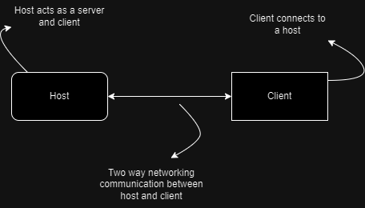

An increasingly complex but more scalable solution for networking following a client server model

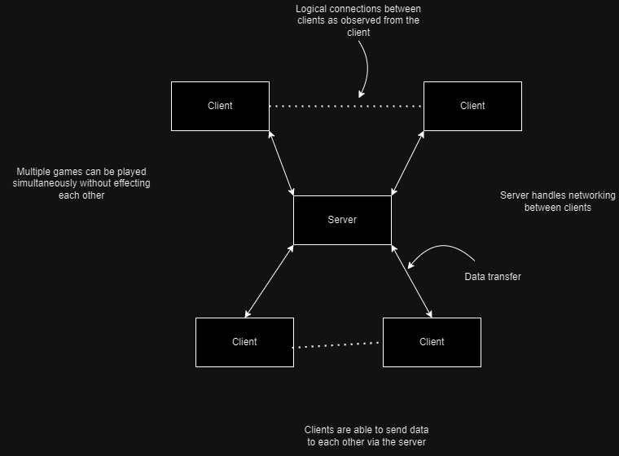

Input device to be used

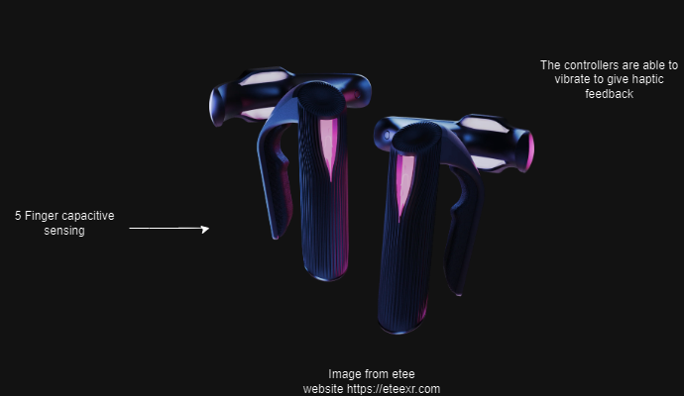

Proposed game loop

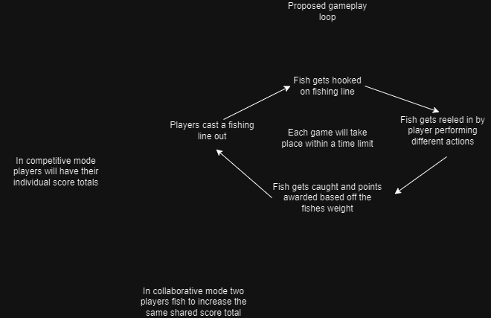

Concept level for game made in unity engine (competitive mode)

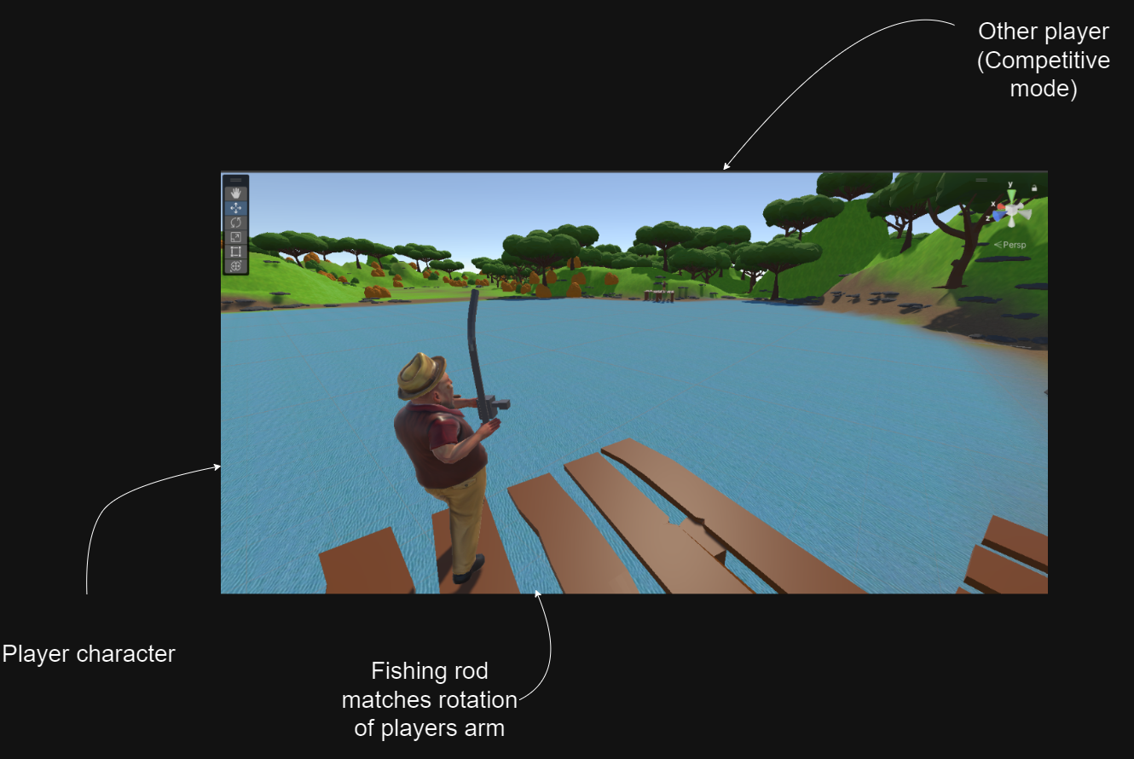

Concept level for game made in unity engine (collaborative mode)

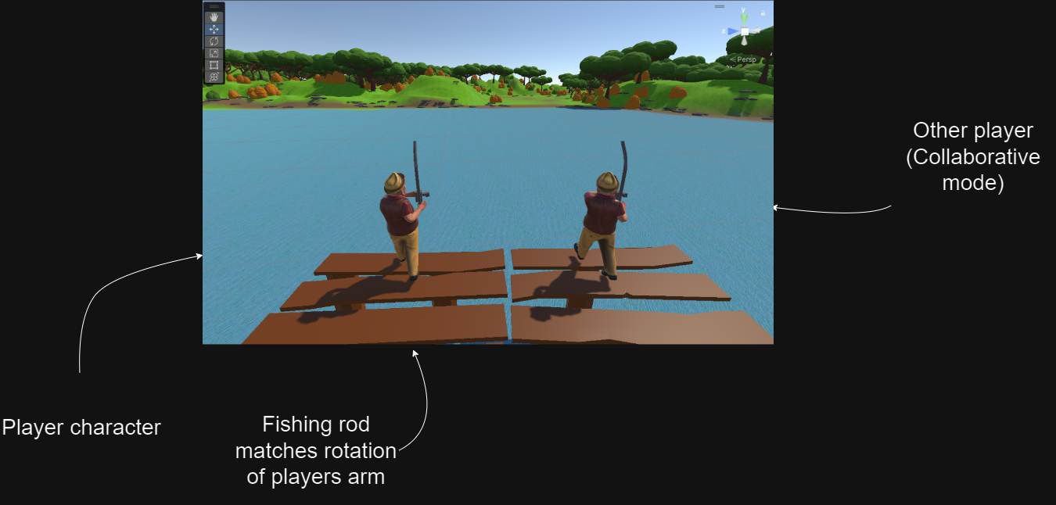

Player model sourced from Mixamo

# Appendix

|  |  |  |  |
| --- | --- | --- | --- |
| Risk assessment issue | How it will be mitigated | Likeliness (1-3) | Severity (1-3) |
| Hygiene issues | Antiseptic wipes | 3 | 1 |
| Controller damage | Controllers will be transported in their original packaging. | 2 | 3 |
| Hardware issues | GitHub source control and computer transport bag | 2 | 2 |
| Limited access to field specialists | Information will mostly be gathered independently. | 3 | 1 |
| Inexperience using unity networking solution | Unity has very good documentation and community to aid learning. | 3 | 2 |
| First time developing using etee API | Reaching out to members/developers at etee for support if issues arise. | 3 | 2 |
| No access to contemporary home therapy equipment | Use non equipment therapies to compare against for user motivation. | 3 | 1 |
| Implementation issues | Tasks will be well planned and broken down. This will allow the scope of the project to be realistic at conception and will allow the scope to be intelligently adjusted to ensure the project finishes on time. | 3 | 2 |
| Unable to access or create art assets for the game | By keeping the game world small the art assets required are limited decreasing the probability of missing assets. | 2 | 2 |
| Use of copyright material | Any third-party assets will be checked for copyright. | 3 | 3 |
| External responsibilities (work and other modules) | Same as implementation issues. | 3 | 3 |

|  |  |  |  |
| --- | --- | --- | --- |
| Task Name | Task Description | Date Start | Date End |
| Research into existing systems (Literature review) | Research looking at conventional therapy options and what movements/exercises they use. Additionally, investigation into game design of upper limb rehabilitation serious games will be conducted | 12/10/2024 | 25/11/2024 |
| Use research to design game | A small design document will be produced. Additionally, an exhaustive task list will be created. Each task having a cost and priority ranked 1 – 3 break each task down into its atomic elements | 25/11/2024 | 05/12/2024 |
| Design interaction | This will require consideration to be taken into how the user will interact with the game, utilizing etee controllers, in a simple and effective way. | 25/11/2024 | 05/12/2024 |
| Game menu and flow design | What menus will be present in the game will be designed as well as the flow of using the system. | 25/11/2024 | 05/12/2024 |
| Game loop design | Design in the moment-to-moment gameplay will be considered | 25/11/2024 | 05/12/2024 |
| Meta game design | This design focuses on the gameplay of an entire game/ play session | 25/11/2024 | 05/12/2024 |
| Sound design | What sounds will be needed | 25/11/2024 | 05/12/2024 |
| UI design | Each menu and UI will have to be designed. | 25/11/2024 | 05/12/2024 |
| Development cycle 1 | Development cycle 1 will consist of setting up the multiplayer and etee controls. Basic menus and placeholder UI will be created. A prototype White box level will be created along with some simple interaction. | 10/12/2024 | 25/12/2024 |
| Development cycle 2 | The gameplay will be completed in this phase. Game interaction will be continuously tested for ease of use. 3d art will be added to the game. | 25/12/2024 | 15/01/2025 |
| Prototype testing | The prototype will be tested to see if users can use the game easily and if it is encouraging the movements intended | 15/01/2025 | 25/01/2025 |
| Development cycle 3 | The final phase of development will be dedicated to polishing the game, this includes responding to tester feedback, adding in art, sound effects and complete menus. | 10/02/2025 | 15/03/2025 |
| Plan for testing of the effectiveness of the game | Time will need to be taken to consider how the testing will be conducted and preparing resources for the testing such as printing off resources such as how to use the controllers, how to play the game etc… | 25/11/2024 | 10/12/2024 |
| Testing the effectiveness of the game | The actual testing of the game will look to gather adult participants to test the game. The success of the project can then be evaluated. | 15/03/2025 | 28/04/2025 |

## A graph with colorful squares Description automatically generated with medium confidenceGantt Chart

# References

[1] Alankus, G., Lazar, A., May, M. and Kelleher, C., 2010, April. Towards customizable games for stroke rehabilitation. In *Proceedings of the SIGCHI conference on human factors in computing systems* (pp. 2113-2122).

[2] Amorim, P., Santos, B.S., Dias, P., Silva, S. and Martins, H., 2020. Serious games for stroke telerehabilitation of upper limb-a review for future research. *International journal of telerehabilitation*, *12*(2), p.65.

[3] Baur, K., Schättin, A., de Bruin, E.D., Riener, R., Duarte, J.E. and Wolf, P., 2018. Trends in robot-assisted and virtual reality-assisted neuromuscular therapy: a systematic review of health-related multiplayer games. *Journal of neuroengineering and rehabilitation*, *15*, pp.1-19.

[4] Borghese, N.A., Pirovano, M., Mainetti, R. and Lanzi, P.L., 2012, September. An integrated low-cost system for at-home rehabilitation. In *2012 18th International conference on virtual systems and multimedia* (pp. 553-556). IEEE.

[5] Chen, C.H., Kreidler, T. and Ochsenfahrt, A., 2022. Rehago–A home-based training app using virtual reality to improve functional performance of stroke patients with mirror therapy and gamification concept: A pilot study. In *Healthcare of the Future 2022* (pp. 91-95). IOS Press.

[6] Choi, Y.H. and Paik, N.J., 2018. Mobile game-based virtual reality program for upper extremity stroke rehabilitation. *Journal of visualized experiments: JoVE*, (133), p.56241.

[7] Cordeiro d'Ornellas, M., Cargnin, D.J. and Cervi Prado, A.L., 2015. Evaluating the impact of player experience in the design of a serious game for upper extremity stroke rehabilitation. In *MEDINFO 2015: eHealth-enabled Health* (pp. 363-367). IOS Press.

[8] Day, M. (2018) *Virtual Reality Exposure Therapy as a Treatment for Social Anxiety Disorders*. Faculty of Computing, Engineering and the Built Environment.

[9] Doumas, I., Everard, G., Dehem, S. and Lejeune, T., 2021. Serious games for upper limb rehabilitation after stroke: a meta-analysis. *Journal of neuroengineering and rehabilitation*, *18*, pp.1-16.

[10] Ferraris, C., Amprimo, G., Vismara, L., Mauro, A. and Pettiti, G., 2023. Enhancing upper limb mobility through gamified tasks and Azure Kinect: a preliminary study in post-stroke.

[11] Gelineau, A., Perrochon, A., Daviet, J.C. and Mandigout, S., 2022. Compliance with Upper Limb Home-Based Exergaming Interventions for Stroke Patients: A Narrative Review. *Journal of rehabilitation medicine*, *54*.

[12] Goff, S. (2020) *Evaluation of the use of Gamification and Augmented Reality Features on Active City Tourism*. Faculty of Computing, Engineering and the Built Environment.

[13] Gov.Uk (2024) Statistical Digest of Rural England – Population. Available at: <https://www.gov.uk/government/statistics/population-statistics-for-rural-england> (Accessed: 10/10/2024)

[14] Guo, X., Edwards, A., 2024. A Case Study of using Web 3D Game Technology for a Scalable Midwifery Training Simulation, in: 2024 IEEE Gaming, Entertainment, and Media Conference (GEM). Presented at the 2024 IEEE Gaming, Entertainment, and Media Conference (GEM), pp. 1–4. <https://doi.org/10.1109/GEM61861.2024.10585499>

[15] Hadjipanayi, C., Banakou, D. and Michael-Grigoriou, D., 2024. Virtual reality exergames for enhancing engagement in stroke rehabilitation: A narrative review. *Heliyon*.

[16] Kecman, B., 2024. *Analysis, Design and Implementation of Serious Game for Upper Limb and Cognitive Training Using Leap Motion for Multiple Sclerosis Patients* (Doctoral dissertation, Technische Universität Wien).

[17] Kempitiya, T., De Silva, D., Rio, E., Skarbez, R. and Alahakoon, D., 2022, July. Personalised physiotherapy rehabilitation using artificial intelligence and virtual reality gaming. In *2022 15th International Conference on Human System Interaction (HSI)* (pp. 1-6). IEEE.

[18] Koutsiana, E., Ladakis, I., Fotopoulos, D., Chytas, A., Kilintzis, V. and Chouvarda, I., 2020. Serious gaming technology in upper extremity rehabilitation: scoping review. *JMIR Serious Games*, *8*(4), p.e19071.

[19] Leniston-Kahsai, S., 2020. *Mirror VR: The design of a fully immersive virtual reality game for upper limb rehabilitation post-stroke using mirror therapy* (Doctoral dissertation, Open Access Te Herenga Waka-Victoria University of Wellington).

[20] Ning, H., Wang, Z., Li, R., Zhang, Y. and Mao, L., 2022. A Review on Serious Games for Exercise Rehabilitation. *arXiv preprint arXiv:2201.04984*.

[21] Pan, W., 2018. *Improving the Motivation and Participation of Elderly Patients in Rehabilitation Program Through Social Games* (Doctoral dissertation, National University of Singapore (Singapore)).

[22] Pinto, J.F., Carvalho, H.R., Chambel, G.R., Ramiro, J. and Gonçalves, A., 2018, May. Adaptive gameplay and difficulty adjustment in a gamified upper-limb rehabilitation. In *2018 IEEE 6th international conference on serious games and applications for health (SeGAH)* (pp. 1-8). IEEE.

|  |
| --- |
|  |

[23] Shahmoradi, L., Almasi, S., Ahmadi, H., Bashiri, A., Azadi, T., Mirbagherie, A., Ansari, N.N. and Honarpishe, R., 2021. Virtual reality games for rehabilitation of upper extremities in stroke patients. *Journal of bodywork and movement therapies*, *26*, pp.113-122.

[24] Strong, B.L., Zeng, B., McCarthy, P., Roula, A. and Guo, L., 2022, July. Virtual Reality Mirror Therapy (VRMT) to Improve Finger Dexterity in Post-stroke Survivors: A Preliminary Feasibility Study of a Home-based Intervention. In *35th International BCS Human-Computer Interaction Conference* (pp. 1-7). BCS Learning & Development.

[25] Tamayo-Serrano, P., Garbaya, S. and Blazevic, P., 2018. Gamified in-home rehabilitation for stroke survivors: analytical review. *International Journal of Serious Games*, *5*(1), pp.2384-8766.

[26] The University of British Columbia (2021). Available at: <https://neurorehab.med.ubc.ca/grasp/grasp-manuals-and-resources/grasp-instruction-manual-2/> (Accessed: 10/10/2024)

[27] Toledo-Delgado, P., PadrÃ³n, M., Santos, E. and Cairos, M., 2013. Including gamification techniques in the design of TANGO: H platform. *Jurnal Teknologi*, *63*(3).

[28] Triandafilou, K.M., Tsoupikova, D., Barry, A.J., Thielbar, K.N., Stoykov, N. and Kamper, D.G., 2018. Development of a 3D, networked multi-user virtual reality environment for home therapy after stroke. *Journal of neuroengineering and rehabilitation*, *15*, pp.1-13.

[29] Vieira, C., da Silva Pais-Vieira, C.F., Novais, J. and Perrotta, A., 2021. Serious game design and clinical improvement in physical rehabilitation: systematic review. *JMIR Serious Games*, *9*(3), p.e20066.

[30] What is a PICOC? » CEBMa [WWW Document], n.d. URL <https://cebma.org/resources/frequently-asked-questions/what-is-a-picoc/> (accessed 10.29.24).

[31] Zhao, P. and Krebs, H.I., 2024, September. Enabling Home Rehabilitation with Smartphone-Powered Upper Limb Training. In *2024 10th IEEE RAS/EMBS International Conference for Biomedical Robotics and Biomechatronics (BioRob)* (pp. 438-443). IEEE.

# Bibliography

The University of British Columbia (2021). Available at: <https://neurorehab.med.ubc.ca/grasp/grasp-manuals-and-resources/hospital-grasp-patient-exercise-manual-form/> (Accessed: 10/10/2024)

Mixamo [WWW Document], n.d. URL <https://www.mixamo.com/#/> (accessed 11.25.24).